Assessment Project Full Report
  - SEC-202: Secure Startup

Team Member:
- [Your Full Name] – [Your Nickname] – [Your Email Address]
- [Your Full Name] – [Your Nickname] – [Your Email Address]
- [Your Full Name] – [Your Nickname] – [Your Email Address]
- [Your Full Name] – [Your Nickname] – [Your Email Address]

Company Name: [Put your company name here]

Company Description [25 Points]:
Write a section of paragraph to comprehensively describe your mock startup company. The section should serve as an executive summary, providing a high-level overview of the company operations, products, and hierarchies. The following topics must be included in this section:
- Key Company Goals, Visions, and Strategies
- Main Product(s) or Service(s) that the company offers to its clients.
- Budgeting Situation that emphasizes the budget for security investment.
- Expected Outcomes of the Security Program
Please justify the rationale behind each topic to make readers understand the current situation of the mock startup company.

Company Operation Procedures [35 Points]:
Write a section of paragraphs that explains the company’s Standard Operating Procedures (SOP) and how they streamline operations. Include a contextual diagram that shows the steps and intermediate outcomes throughout the process. A collection of contextual-diagram notations is provided below.
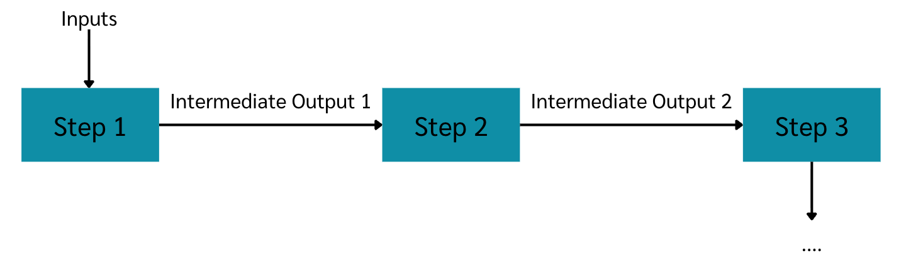
In addition to the diagram, provide a detailed explanation of each step so that readers can clearly understand the operation.
Data and Information Assets in the Company [40 Points]:
List all data and information assets of the mock-startup company. Remember that assets include not only data stored in information-processing systems but any information-bearing item across the whole organization. Present the assets in a numbered list, explain the purpose of each asset to justify its value, and identify the sensitivity classification for each asset.
Example
- Employment contracts for employees – This document asset contains the contracts signed between the company representative and each employee and is classified as confidential information. The contracts are important because they define the scope of roles and responsibilities for each employee, and they serve as evidence of employee acknowledgment.
- …

Access Control Matrix of the Company Valuable Assets [30 Points]:
Create an access-control matrix similar to the one we produced in Lab 1. Compile all stakeholders who can access the assets, and design your own permission notation for the matrix (e.g., Y/N for yes/no, R/W for read/write, etc.). You must also write a paragraph (or several paragraphs) that explains the access-control matrix you created and justifies the reasoning behind it.

Risk of the Company [50 Points]:
Using the risk-identification and mitigation techniques we explored in class, please conduct a comprehensive risk assessment for your mock startup. Start by listing all possible risks across five categories: Strategic, Financial, Operational, Compliance, and Reputational. For each risk, determine its likelihood (Use the 1–5 scale we practiced) and potential impact (likelihood × severity). Apply the “5 Whys” to drill down to root causes and then propose at least two realistic mitigation strategies per risk, specifying responsible parties and timelines. Summarise your findings in a concise paragraph, attaching a risk matrix visual you create.

Vendor Management Framework [30 Points]:
Write a section of paragraphs that comprehensively explains how you manage vendors in your mock-startup company. It is obvious that your company may need to use or integrate with third-party services and applications; however, it is insecure to fully trust a vendor with the handling or processing of the company’s sensitive information. Apply the knowledge from the lectures to define a plan and procedure for handling vendors that provide services to your company or that require data and information from your company. The content can be written in any format that demonstrates your understanding and the thinking process behind the design of your vendor-management procedures.

Compliance with Regulations and Security Controls [30 Points]:
Write a section of paragraphs describing how your mock startup company plans for compliance with regulations. You must select at least two security or privacy regulations as targets for compliance. You must then explain why your company must comply with these regulations. You must list all security controls, principles, or obligations defined in those regulations and extract a set of common controls for your company's security and privacy. Finally, you must suggest ways your company can comply with those controls.

Design of your Company Infrastructure and Processes [60 Points]:
Write a section of paragraphs that fully explains the organizational design of the mock startup company. Include a top-level deployment diagram that illustrates an overview of the company’s infrastructure and shows how it is secured from multiple perspectives. Provide at least one paragraph describing the top-level deployment diagram and explaining the thinking process behind the infrastructure design.
Additionally, include a set of detailed flowcharts that depict the operational procedures you have designed. Provide at least one paragraph that explains each procedure and the reasoning behind its creation.

